Assignment No : 1

Q1. Write a Python program to print the following string in a specific format ?
Out put :
Twinkle, twinkle, little star,
How I wonder what you are!
Up above the world so high,
Like a diamond in the sky.
Twinkle, twinkle, little star,
How I wonder what you are .

print("Twinkle, twinkle, little star,\n"
"How I wonder what you are!\n"
"Up above the world so high,\n"
"Like a diamond in the sky.\n"
"Twinkle, twinkle, little star,\n"
"How I wonder what you are")

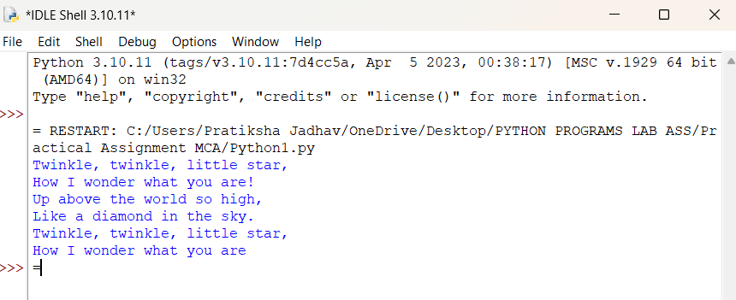

Q2. Write a program to perform arithmetic operations.

a = float(input("Enter first number: "))
b = float(input("Enter second number: "))
add = a + b
sub = a - b
mul = a * b
div = a / b if b != 0 else "Undefined (division by zero)"
print("Addition:", add)
print("Subtraction:", sub)
print("Multiplication:", mul)
print("Division:", div)
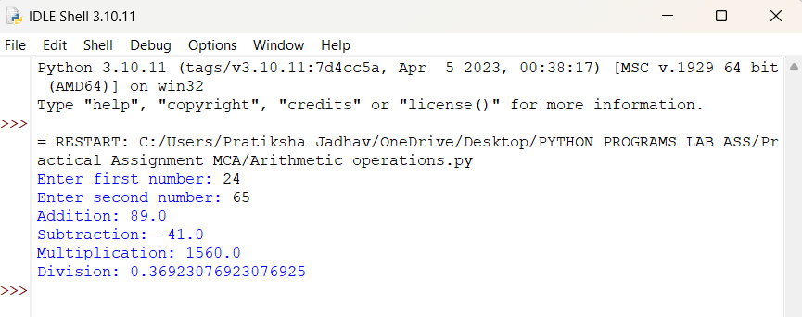

Q3. Write a program using list to perform below operation:
a. Slicing
b. Concatenation
c. Repetition
lst1 = [1, 2, 3, 4, 5]
lst2 = ['a', 'b', 'c']
print("Slicing:", lst1[1:4])
print("Concatenation:", lst1 + lst2)
print("Repetition:", lst2 * 3)

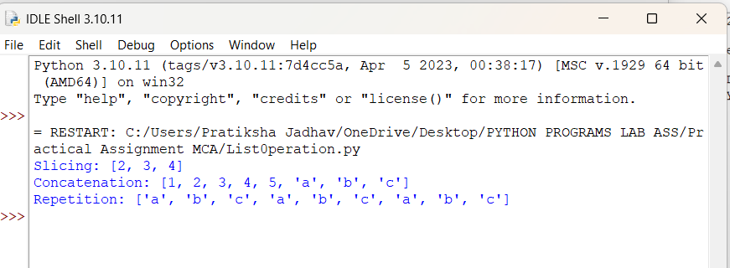
Q4. Write a program using tuple to perform below operation:
a. Slicing
b. Concatenation
c. Repetition

t1 = (1, 2, 3, 4, 5)
t2 = ('a', 'b', 'c')
print("Slicing:", t1[1:4])
print("Concatenation:", t1 + t2)
print("Repetition:", t2 * 3)

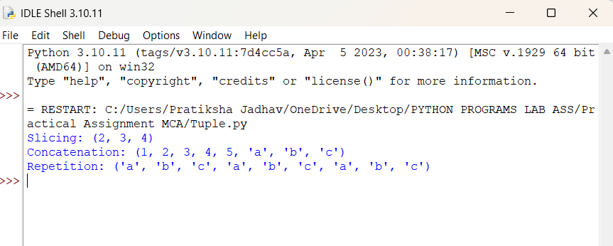

Q5. Write a program using dictionary to access value using keys

car = {"brand": "Toyota", "model": "Corolla", "year": 2020}
print(car["brand"])
print(car["model"])
print(car["year"])

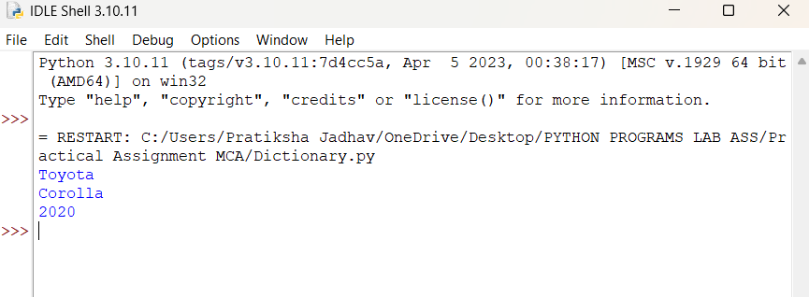
Q6. Write a program using set:
a. Create empty set
b. Assign value to set
c. Adding element
d. Removing element

s = set()
s = {"apple", "banana"}
s.add("orange")
s.remove("banana")
print(s)

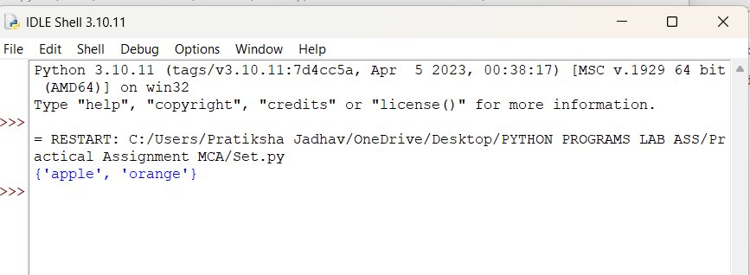

Q7. Write a program to get the largest number from the given list ?

numbers = [12, 45, 7, 89, 23]
print("List is : ",numbers)
print("Largest no is :",max(numbers))

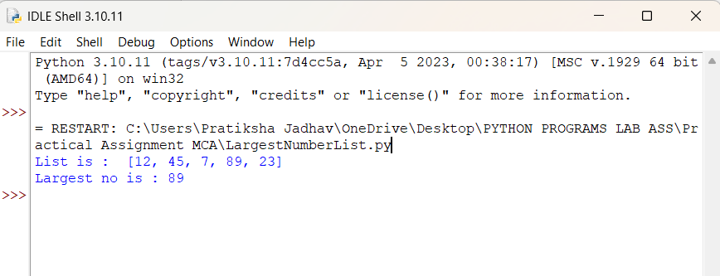
Q8. Write a program to find out Factorial of a given Number

num = int(input("Enter a number: "))
fact = 1
for i in range(1, num + 1):
fact *= i
print("Factorial of", num, "is", fact)
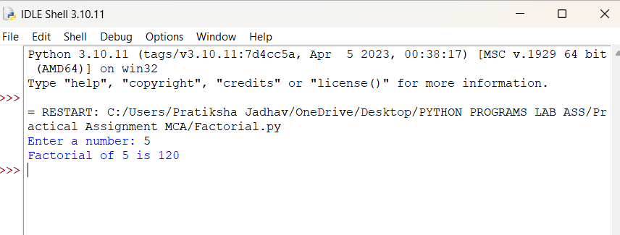

Q9. Write a program to find given number is prime or not.

num = int(input("Enter a number: "))
if num <= 1:
print(num, "is not a prime number")
else:
for i in range(2, int(num**0.5) + 1):
if num % i == 0:
print(num, "is not a prime number")
break
else:
print(num, "is a prime number")

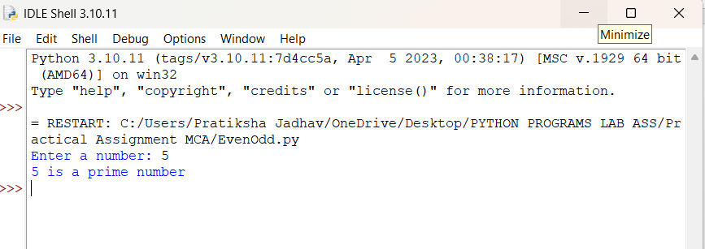
Q10. Write a program to identify total number of digits present in given number.

num = int(input("Enter a number: "))
count = 0
n = abs(num) # handle negative numbers also

if n == 0:
count = 1
else:
while n > 0:
n //= 10
count += 1

print("Total number of digits:", count)

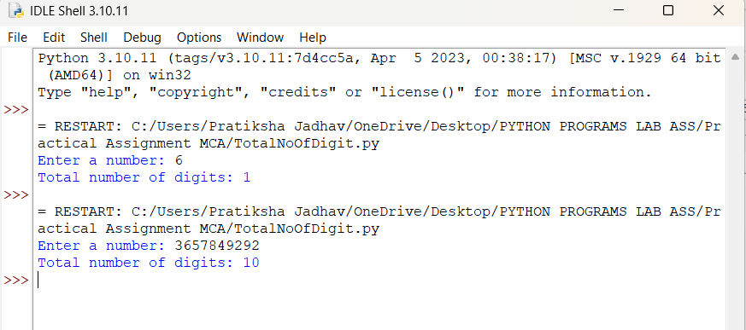

Q11. Write a program to display Fibonacci series up to a given number by using range function.

limit = int(input("Enter the limit: "))

a, b = 0, 1

print("Fibonacci series:")

for _ in range(limit):
print(a, end=" ")
a, b = b, a + b

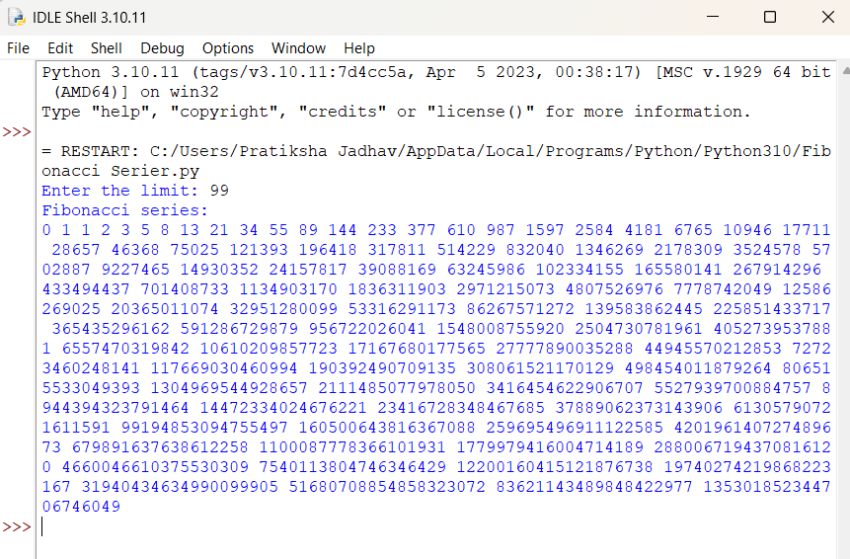

Q12. Write a program using for loop with:
String, Integer, Enumerate, Nested For,
List, Dictionary, Tuple, Zip()

# 1. For loop with String
print("\n--- For Loop with String ---")
text = "HELLO"
for ch in text:
print(ch)

# 2. For loop with Integer (range)
print("\n--- For Loop with Integer using range() ---")
for i in range(1, 6):
print(i)

# 3. For loop with Enumerate
print("\n--- For Loop with Enumerate ---")
fruits = ["Apple", "Banana", "Cherry"]
for index, item in enumerate(fruits):
print(index, item)

# 4. Nested For Loop
print("\n--- Nested For Loop ---")
for i in range(1, 4):
for j in range(1, 4):
print(f"({i}, {j})")

# 5. For Loop with List
print("\n--- For Loop with List ---")
numbers = [10, 20, 30, 40]
for n in numbers:
print(n)

# 6. For Loop with Dictionary
print("\n--- For Loop with Dictionary ---")
student = {"name": "John", "age": 20, "marks": 85}
for key, value in student.items():
print(key, ":", value)

# 7. For Loop with Tuple
print("\n--- For Loop with Tuple ---")
t = (5, 10, 15, 20)
for item in t:
print(item)

# 8. For Loop with zip()
print("\n--- For Loop with zip() ---")
names = ["John", "Alice", "Bob"]
scores = [85, 90, 78]
for n, s in zip(names, scores):
print(n, "=>", s)

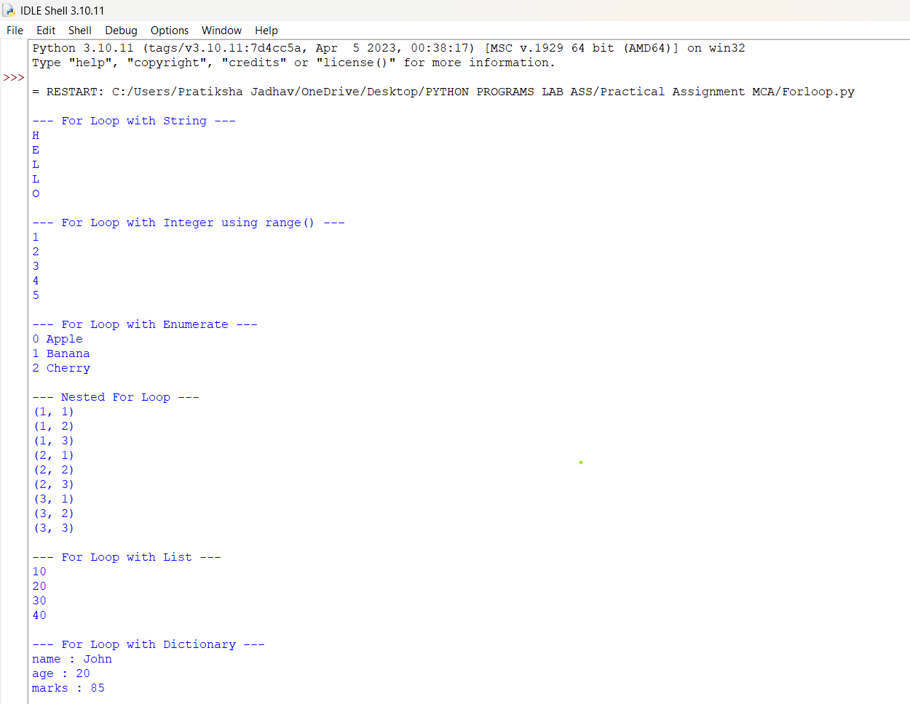
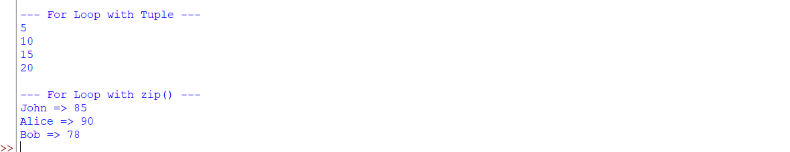
Q13. Write a program to perform Loop manipulation using pass, continue, break and else

print("\n--- Using pass ---")
for i in range(1, 6):
if i == 3:
pass # pass does nothing, just a placeholder
print("Value:", i)

print("\n--- Using continue ---")
for i in range(1, 6):
if i == 3:
continue # skips printing 3 and moves to next iteration
print("Value:", i)

print("\n--- Using break ---")
for i in range(1, 6):
if i == 3:
break # loop stops completely when i = 3
print("Value:", i)

print("\n--- Using else with loop ---")
for i in range(1, 6):
print("Value:", i)
else:
# This runs only when loop finishes normally (not stopped by break)
print("Loop completed successfully!")

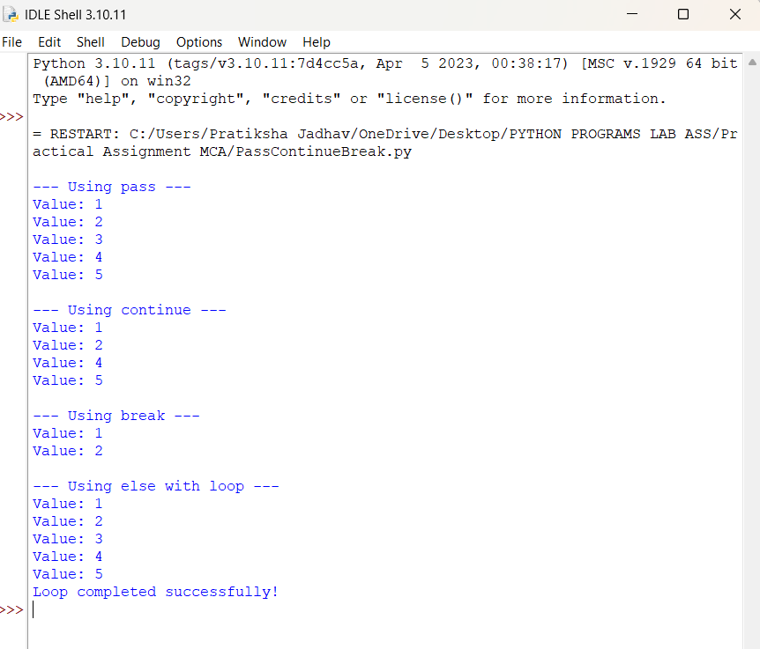
Q14. Write a program to perform Comprehensions on List Dictionaries.

# List comprehension
numbers = [1, 2, 3, 4, 5]
squares = [n*n for n in numbers] # square of each number
print("Squares:", squares)

# Dictionary comprehension
students = ["John", "Alice", "Bob"]
marks = [85, 90, 78]

student_dict = {name: mark for name, mark in zip(students, marks)} # map names to marks
print("Student Dictionary:", student_dict)

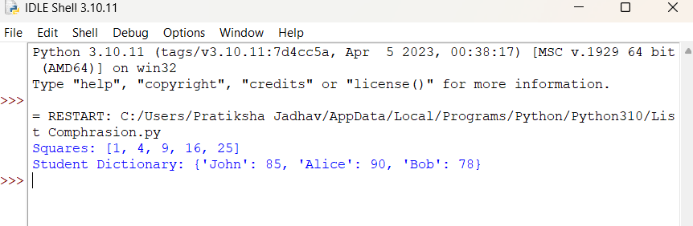

Q15. Write a program to Find all the numbers from 1-500 that have three in them.

# Print numbers from 1 to 500 that contain digit 3
for num in range(1, 501):
if '3' in str(num):
print(num)

# Store numbers in a list
nums_with_three = [num for num in range(1, 501) if '3' in str(num)]
print(nums_with_three)

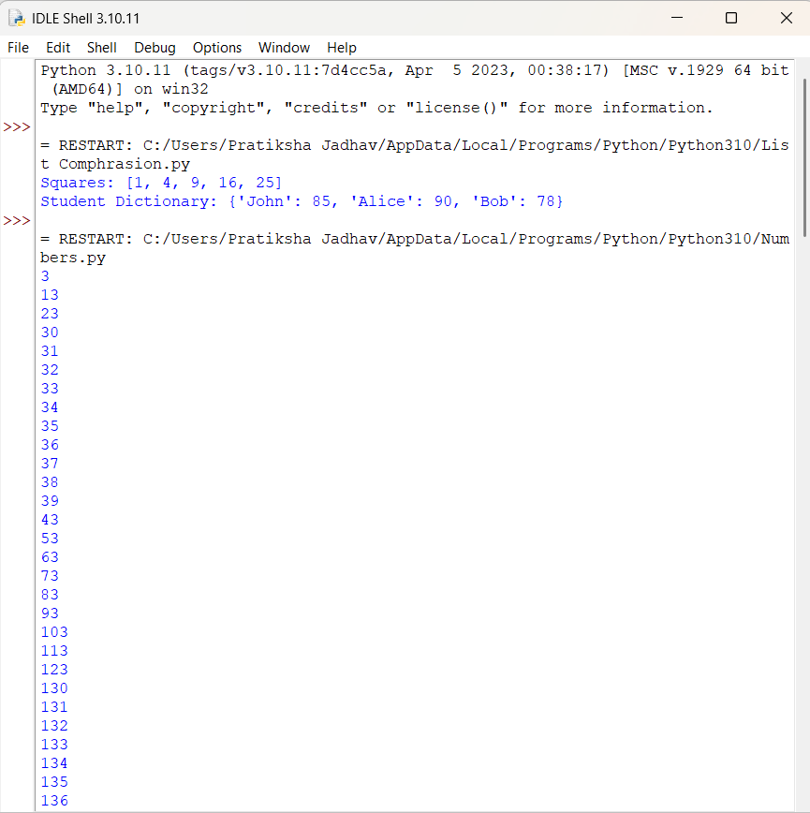
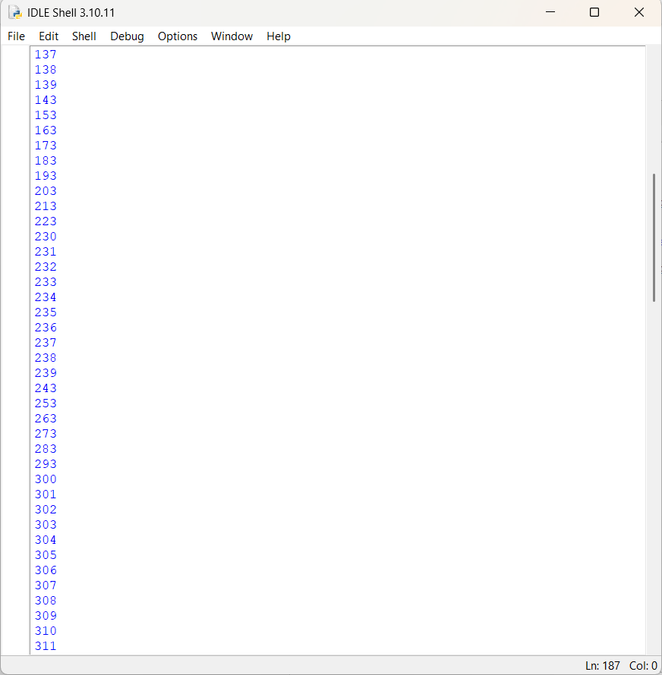
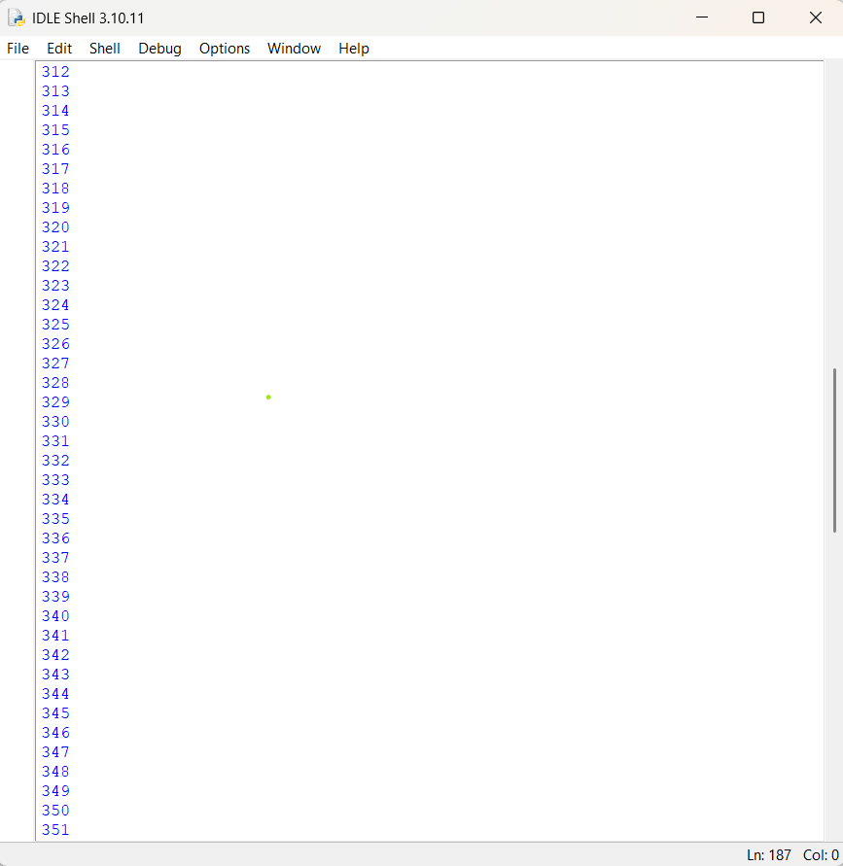
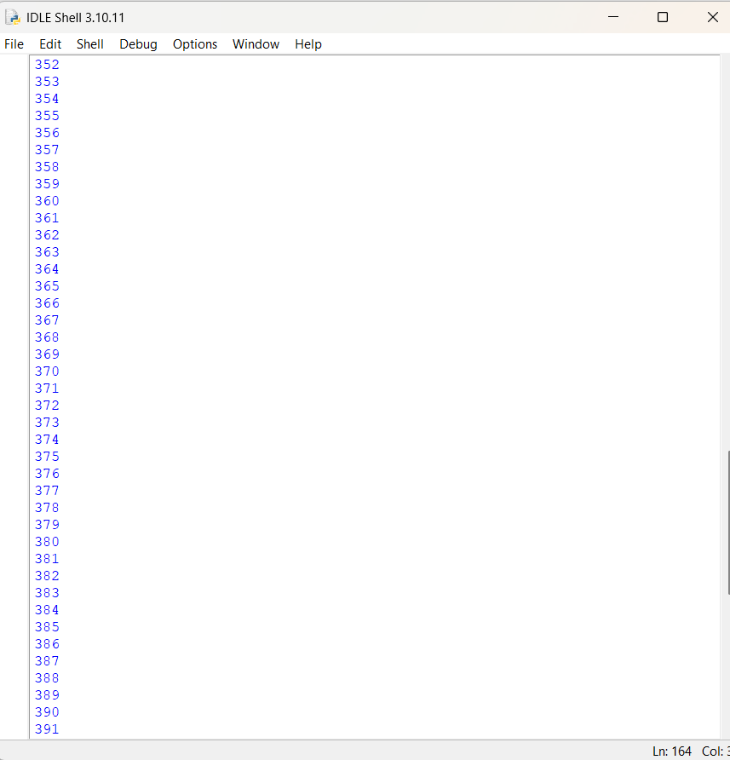
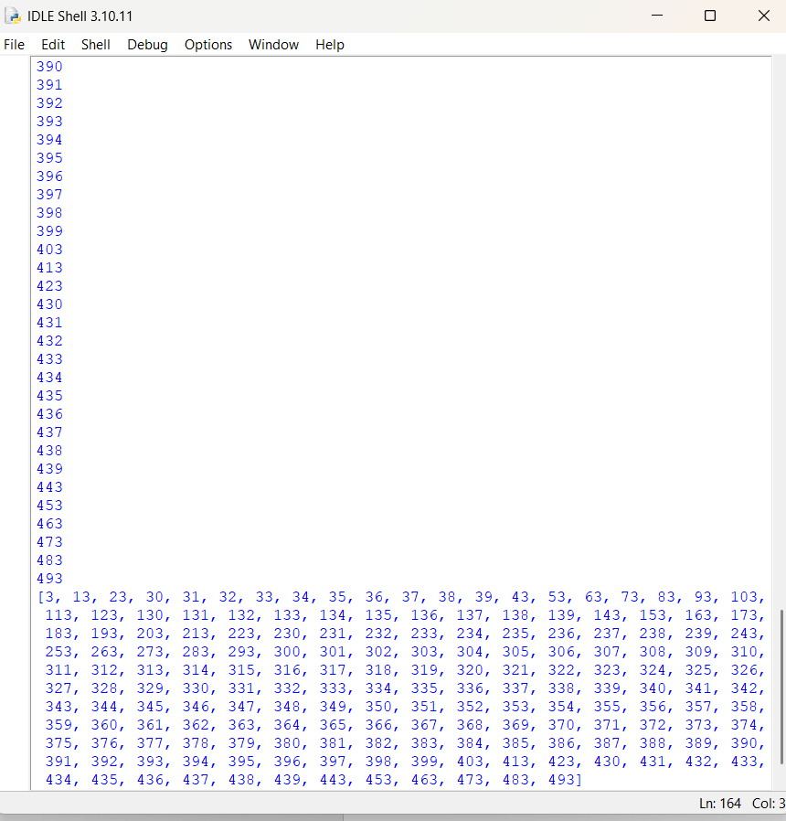
Q16 . Write a python program for numbers=range(20) produce a list containing the word "even" if the number is even or the word "odd" if the number is odd

numbers = range(20)
result = ["even" if n % 2 == 0 else "odd" for n in numbers]
print(result)

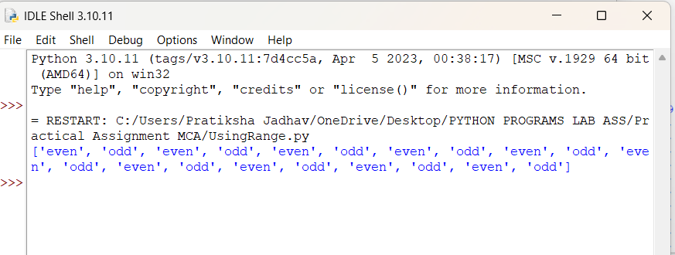

Q17. Find the common numbers in two list
1[1,3,4,5,6,7]
2[5,2,8,7,1,3]

list1 = [1, 3, 4, 5, 6, 7]
list2 = [5, 2, 8, 7, 1, 3]
common = [num for num in list1 if num in list2]
print("Common Numbers:", common)

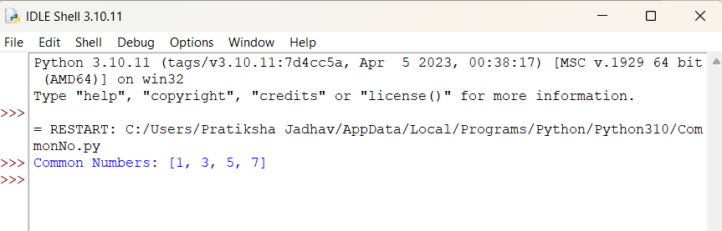
Assignment No : 2

Q1. Implement a nested function that calculates compound interest using non-local variables

def compound_interest():
principal = 0
rate = 0
time = 0

def set_values(p, r, t):
nonlocal principal, rate, time
principal = p
rate = r
time = t
def calculate():
amount = principal * (1 + rate/100) ** time
return amount
set_values(1000, 5, 2) # Example: P=1000, R=5%, T=2 years
return calculate()

result = compound_interest()
print("Compound Interest Amount:", result)

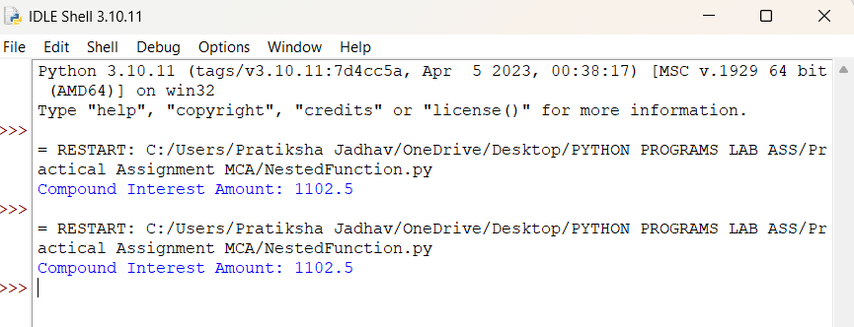

Q2. Write a program using lambda to filter even numbers from a list

numbers = [1, 2, 3, 4, 5, 6, 7, 8, 9, 10]
print("Numbers :",numbers)
even_numbers = list(filter(lambda x: x % 2 == 0, numbers))
print("Even Numbers:", even_numbers)

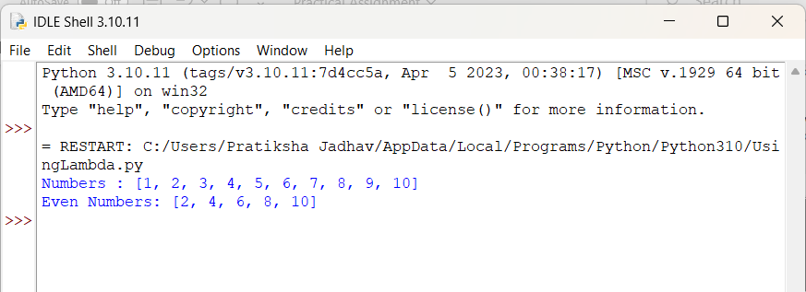

Q3. Write a program using lambda to find area of triangle

area = lambda base, height: 0.5 * base * height
b = float(input("Enter base: "))
h = float(input("Enter height: "))
print("Area of Triangle:", area(b, h))

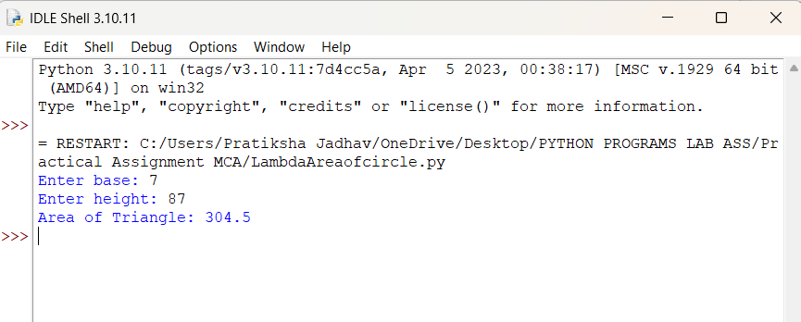
Q4. Create a generator function to yield Fibonacci numbers up to a certain limit

def fibonacci(limit):
a, b = 0, 1
while a <= limit:
yield a
a, b = b, a + b
limit = int(input("Enter limit: "))
for num in fibonacci(limit):
print(num, end=" ")

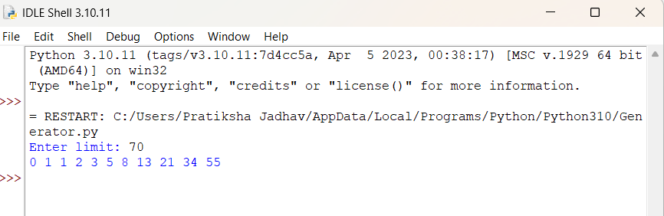

Q5. Develop a custom Python module with functions for basic statistical operations (mean,median,mode) .

# mystats.py
# Custom module for basic statistical operations

def mean(data):
return sum(data) / len(data)

def median(data):
sorted_data = sorted(data)
n = len(sorted_data)

mid = n // 2
if n % 2 == 0:
return (sorted_data[mid - 1] + sorted_data[mid]) / 2
else:
return sorted_data[mid]

def mode(data):
frequency = {}
for num in data:
frequency[num] = frequency.get(num, 1) + 1
max_count = max(frequency.values())
modes = [key for key, value in frequency.items() if value == max_count]

if len(modes) == 1:
return modes[0]
else:
return modes # multiple modes

# main.py

import mystats
numbers = [1, 2, 2, 3, 4, 5]
print("Mean:", mystats.mean(numbers))
print("Median:", mystats.median(numbers))
print("Mode:", mystats.mode(numbers))

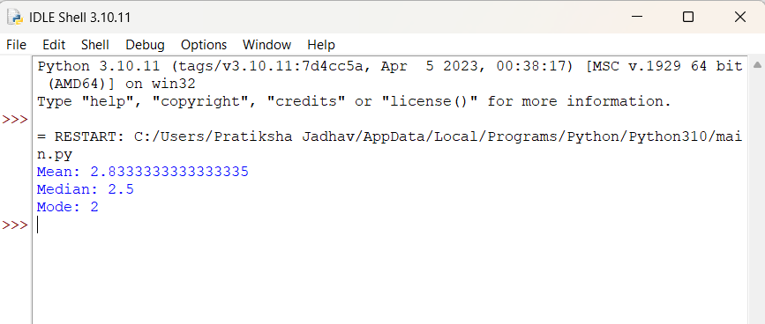

Q6. Write a program to handle file reading errors and log them to a separate file

def read_file(filename):
try:
with open(filename, "r") as file:
data = file.read()
print("File Content:\n", data)

except FileNotFoundError as e:
log_error(f"FileNotFoundError: {e}")

except PermissionError as e:
log_error(f"PermissionError: {e}")

except Exception as e:
log_error(f"Other Error: {e}")

def log_error(message):
with open("error_log.txt", "a") as log:
log.write(message + "\n")
print("Error logged:", message)

filename = input("Enter file name to read: ")
read_file(filename)

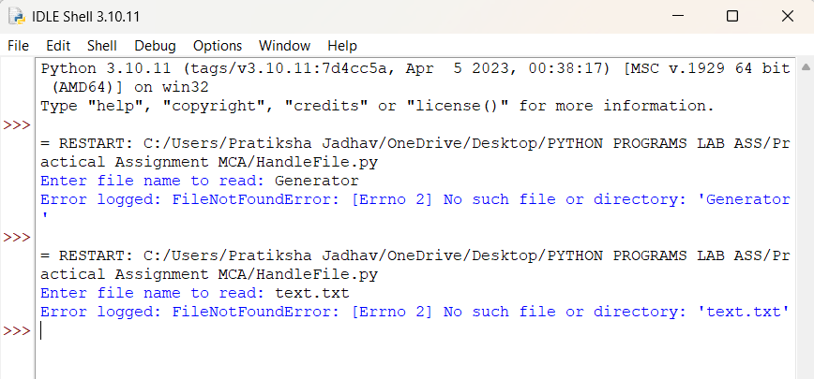

Q7. Create a custom exception class AgeException and use it to validate user input

class AgeException(Exception):
pass # custom exception class
try:
age = int(input("Enter your age: "))
if age < 0:
raise AgeException("Age cannot be negative")
elif age < 18:
raise AgeException("Age must be 18 or above")
print("Age is valid!")
except AgeException as e:
print("Age Error:", e)

except ValueError:
print("Invalid input! Please enter a number.")

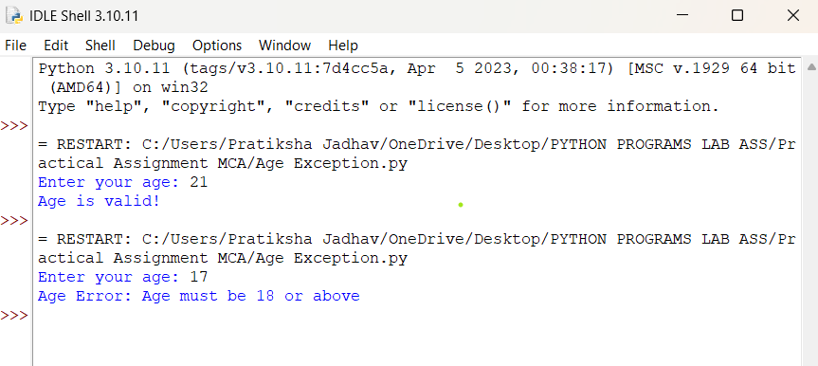
Assignment No : 3

Q1. Write a simple Python class named Student and display its type. Also display the dict attribute keys and values of the_module_attribute of the Student class.

class Student:
def __init__(self, name, roll):
self.name = name
self.roll = roll
s = Student("Alice", 101)
print("Type of s:", type(s))
print("\nObject __dict__ attributes:")
for key, value in s.__dict__.items():
print(key, ":", value)
# display the __dict__ attribute of the class
print("\nClass __dict__ attributes:")
for key, value in Student.__dict__.items():
print(key, ":", value)
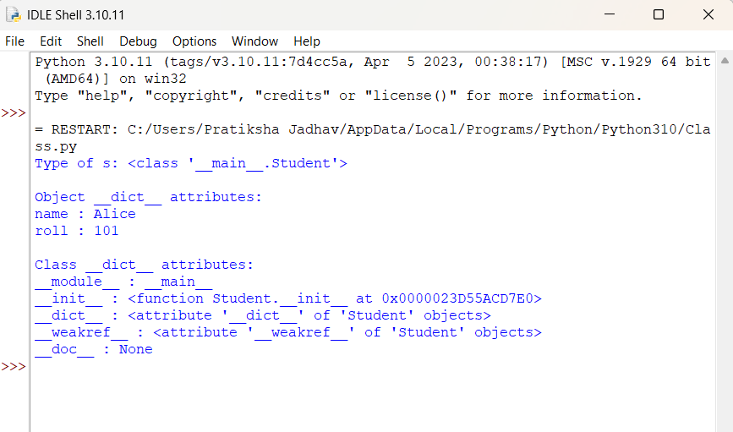
Q2. Write a Python class Student with two attributes, student_name and marks. Modify any attribute value of the class and show the original and modified values of attributes.

class Student:
def __init__(self, student_name, marks):
self.student_name = student_name
self.marks = marks
# create object
s = Student("Pratiksha", 85)
# show original values
print("Original Values:")
print("Name:", s.student_name)
print("Marks:", s.marks)
# modify attributes
s.student_name = "varsha"
s.marks = 80
print("\nModified Values:")
print("Name:", s.student_name)
print("Marks:", s.marks)
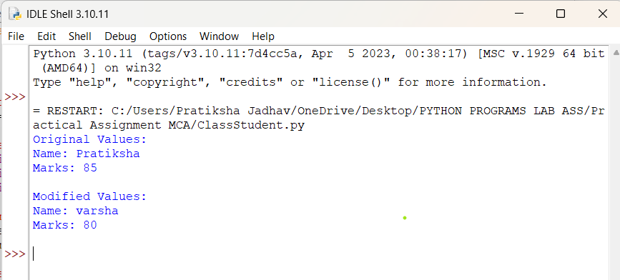
Q3. Write a Python class to convert an integer to a Roman numeral.

class IntegerToRoman:
def __init__(self, number):
self.number = number
def convert(self):
val = [
1000, 900, 500, 400,
100, 90, 50, 40,
10, 9, 5, 4, 1
]
syms = [
"M", "CM", "D", "CD",
"C", "XC", "L", "XL",
"X", "IX", "V", "IV", "I"
]
num = self.number
roman = ""
for i in range(len(val)):
while num >= val[i]:
roman += syms[i]
num -= val[i]
return roman
# Example usage
n = int(input("Enter an integer: "))
converter = IntegerToRoman(n)
print("Roman numeral:", converter.convert())
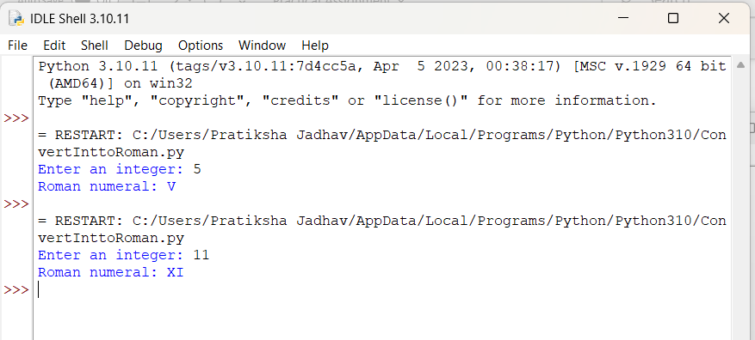

Q4. Write a Python class to convert a Roman numeral to an integer.

class RomanToInteger:
def __init__(self, roman):
self.roman = roman\
def convert(self):
roman_values = {
'I': 1, 'V': 5, 'X': 10, 'L': 50,
'C': 100, 'D': 500, 'M': 1000
}

total = 0
prev_value = 0
for char in reversed(self.roman):
value = roman_values[char]
if value < prev_value:
total -= value
else:
total += value
prev_value = value
return total
roman = input("Enter a Roman numeral: ").upper()
converter = RomanToInteger(roman)
print("Integer:", converter.convert())

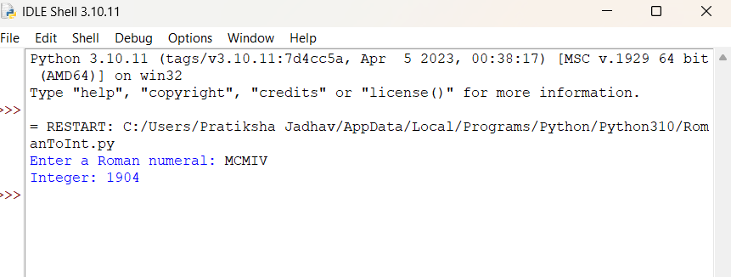

Q5. Write a program to create a class Shape with methods called get_perimeter and get area. Create a subclass called Circle that overrides the get_perimeter and get_area methods to calculate the area and perimeter of a circle.

import math
class Shape:
def get_perimeter(self):
return "Perimeter formula not defined"

def get_area(self):
return "Area formula not defined"

class Circle(Shape):
def __init__(self, radius):
self.radius = radius

def get_perimeter(self):
return 2 * math.pi * self.radius # circumference

def get_area(self):
return math.pi * (self.radius ** 2)

# Example usage
r = float(input("Enter radius of the circle: "))
c = Circle(r)

print("Perimeter of Circle:", c.get_perimeter())
print("Area of Circle:", c.get_area())

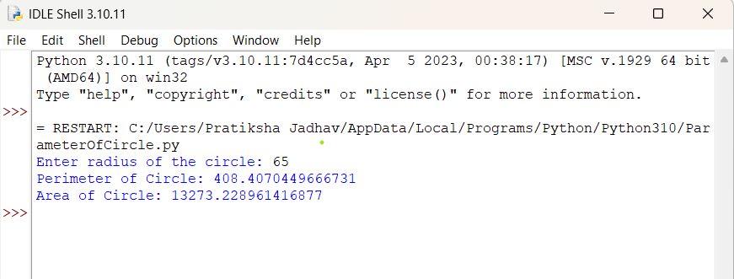

Q6. Write a program to create a Vehicle class hierarchy. The base class should be Vehicle, with subclasses Truck, Car, and Motorcycle. Each subclass should have properties such as make, model, year, and fuel_type. Implement methods for calculating fuel efficiency, distance traveled, and maximum speed.

class Vehicle:
def __init__(self, make, model, year, fuel_type):
self.make = make
self.model = model
self.year = year
self.fuel_type = fuel_type

def fuel_efficiency(self):
return "Fuel efficiency not defined"

def distance_traveled(self, hours, speed):
return hours * speed

def max_speed(self):
return "Max speed not defined"

class Car(Vehicle):
def fuel_efficiency(self):
return 15 # km per liter (example)

def max_speed(self):
return 180 # km/h

class Truck(Vehicle):
def fuel_efficiency(self):
return 8 # km per liter (example)

def max_speed(self):
return 120 # km/h

class Motorcycle(Vehicle):
def fuel_efficiency(self):
return 35 # km per liter (example)
def max_speed(self):
return 160 # km/h

# Example usage
car = Car("Toyota", "Corolla", 2020, "Petrol")
truck = Truck("Volvo", "FH16", 2019, "Diesel")
bike = Motorcycle("Yamaha", "R15", 2023, "Petrol")

print("\n--- Car Info ---")
print("Fuel Efficiency:", car.fuel_efficiency(), "km/l")
print("Max Speed:", car.max_speed(), "km/h")
print("Distance in 2 hours at 80 km/h:", car.distance_traveled(2, 80), "km")

print("\n--- Truck Info ---")
print("Fuel Efficiency:", truck.fuel_efficiency(), "km/l")
print("Max Speed:", truck.max_speed(), "km/h")
print("Distance in 3 hours at 60 km/h:", truck.distance_traveled(3, 60), "km")

print("\n--- Motorcycle Info ---")
print("Fuel Efficiency:", bike.fuel_efficiency(), "km/l")
print("Max Speed:", bike.max_speed(), "km/h")
print("Distance in 1.5 hours at 70 km/h:", bike.distance_traveled(1.5, 70), "km")

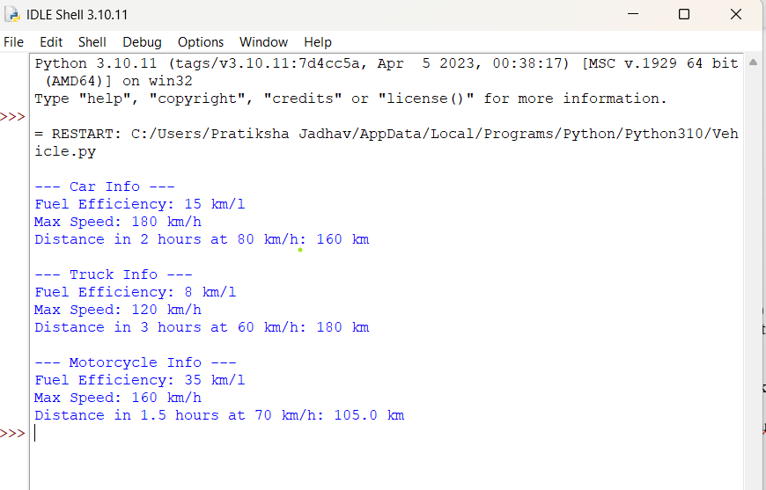
Q7. Implement a class BankAccount with methods for deposit, withdrawal, and displaying the account balance.

class BankAccount:
def __init__(self, account_holder, balance=0):
self.account_holder = account_holder
self.balance = balance

def deposit(self, amount):
self.balance += amount
print(f"Deposited: {amount}")

def withdraw(self, amount):
if amount > self.balance:
print("Insufficient balance!")
else:
self.balance -= amount
print(f"Withdrawn: {amount}")

def display_balance(self):
print(f"Account Holder: {self.account_holder}")
print(f"Current Balance: {self.balance}")

name = input("Enter account holder name: ")
acc = BankAccount(name, 1000)

acc.display_balance()
acc.deposit(500)
acc.withdraw(800)
acc.display_balance()

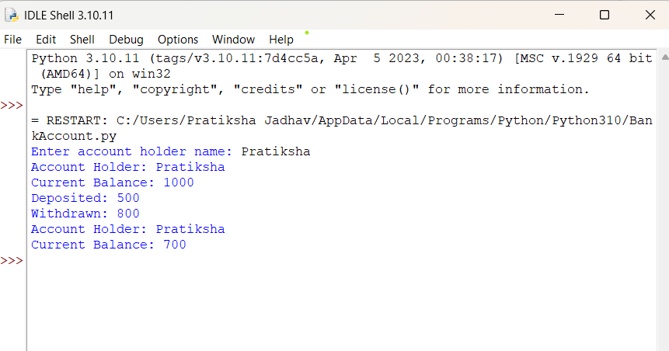
Q8. Develop a hierarchy of shapes (e.g., Shape, Circle, Rectangle) with area and perimeter methods.Student class.

import math

class Shape:
def area(self):
return "Area not defined"

def perimeter(self):
return "Perimeter not defined"

class Circle(Shape):
def __init__(self, radius):
self.radius = radius

def area(self):
return math.pi * self.radius ** 2

def perimeter(self):
return 2 * math.pi * self.radius

class Rectangle(Shape):
def __init__(self, length, width):
self.length = length
self.width = width

def area(self):
return self.length * self.width

def perimeter(self):
return 2 * (self.length + self.width)
# Example usage
c = Circle(5)
r = Rectangle(10, 4)

print("Circle Area:", c.area())
print("Circle Perimeter:", c.perimeter())
print("Rectangle Area:", r.area())
print("Rectangle Perimeter:", r.perimeter())

class Student:
def __init__(self, name, roll_no, marks):
self.name = name
self.roll_no = roll_no
self.marks = marks
def display(self):
print("Student Name:", self.name)
print("Roll Number:", self.roll_no)
print("Marks:", self.marks)
s = Student("Rahul", 101, 89)
s.display()

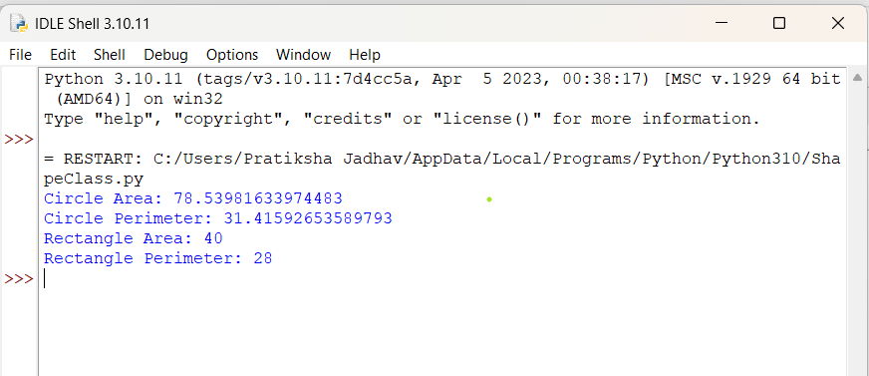
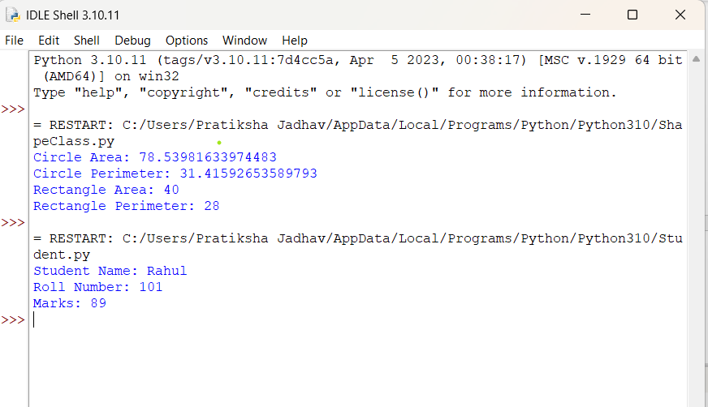

Q9. Overload the + operator for concatenating two custom string objects

class CustomString:
def __init__(self, text):
self.text = text

def __add__(self, other):
return CustomString(self.text + other.text)

def __str__(self):
return self.text

# Example usage
s1 = CustomString("Hello ")
s2 = CustomString("World!")

s3 = s1 + s2 # Using overloaded + operator

print("Concatenated String:", s3)

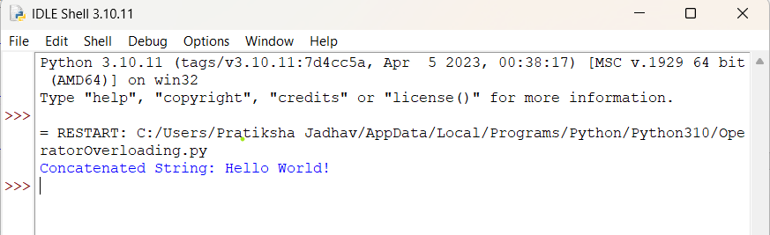

Q10. Create a static method to validate user credentials (e.g., email format, password length).

import re
class Validator:
@staticmethod
def validate_email(email):
pattern = r'^[\w\.-]+@[\w\.-]+\.\w+$'
return re.match(pattern, email) is not None

@staticmethod
def validate_password(password):
return len(password) >= 8

email = input("Enter email: ")
password = input("Enter password: ")

if Validator.validate_email(email):
print("Valid Email")
else:
print("Invalid Email")

if Validator.validate_password(password):
print("Valid Password")
else:
print("Password must be at least 8 characters long")

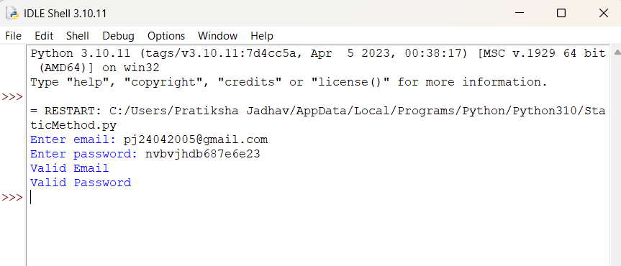
Q 11. Implement a class Library containing a list of Book objects

class Book:
def __init__(self, title, author, year):
self.title = title
self.author = author
self.year = year
def display(self):
print(f"Title: {self.title}, Author: {self.author}, Year: {self.year}")
class Library:
def __init__(self):
self.books = [] # list of Book objects
def add_book(self, book):
self.books.append(book)
print(f"Book '{book.title}' added to library.")

def show_books(self):
if not self.books:
print("No books in library.")
else:
print("\nBooks in Library:")
for book in self.books:
book.display()
b1 = Book("Python Programming", "John Doe", 2020)
b2 = Book("Data Science", "Jane Smith", 2022)

lib = Library()
lib.add_book(b1)
lib.add_book(b2)
lib.show_books()
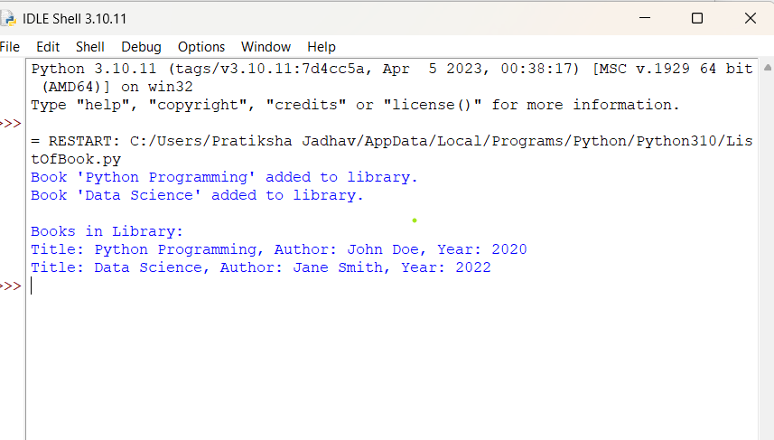
Q12. Demonstrate method overriding in a superclass-subclass relationship for a payment system (e.g., Payment, CardPayment).

class Payment:
def process_payment(self, amount):
print(f"Processing a generic payment of ₹{amount}")

class CardPayment(Payment):
def process_payment(self, amount):
print(f"Processing card payment of ₹{amount}")
print("Payment successful using Debit/Credit Card")

p = Payment()
cp = CardPayment()

print("---- Payment ----")
p.process_payment(500)

print("\n---- Card Payment ----")
cp.process_payment(500)

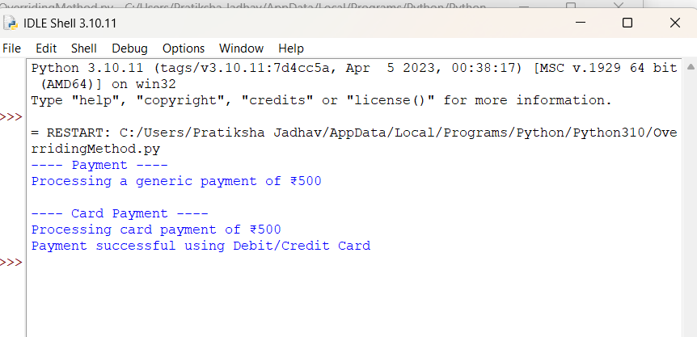

Q 13. Write a program to validate a password that meets certain criteria (length, uppercase, digit, special character).

import re

def validate_password(password):
if len(password) < 8:
return "Password must be at least 8 characters long."

if not re.search(r"[A-Z]", password):
return "Password must contain at least one uppercase letter."

if not re.search(r"[0-9]", password):
return "Password must contain at least one digit."

if not re.search(r"[!@#$%^&*(),.?\":{}|<>]", password):
return "Password must contain at least one special character."

return "Password is valid."

password = input("Enter password: ")
print(validate_password(password))

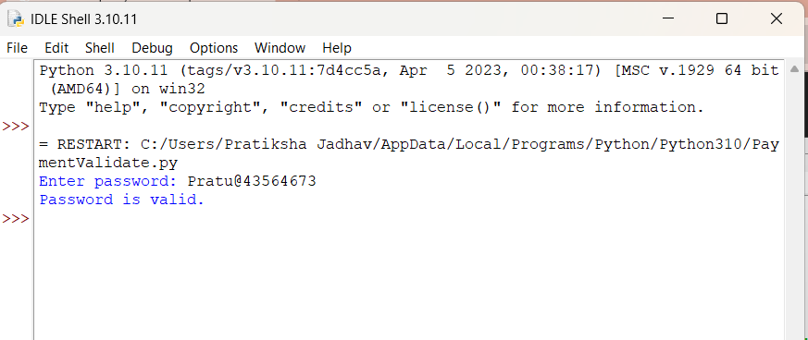

Q 14. Parse email addresses from a given text and classify them by domain.

import re

def classify_emails(text):
pattern = r'[a-zA-Z0-9._%+-]+@[a-zA-Z0-9.-]+\.[a-zA-Z]{2,}'
emails = re.findall(pattern, text)
domain_dict = {}

for email in emails:
domain = email.split("@")[1]
if domain not in domain_dict:
domain_dict[domain] = []
domain_dict[domain].append(email)

return domain_dict
text = """
Contact us at support@gmail.com or sales@yahoo.com.
You can also reach admin@company.com and hr@company.com
for further queries. Backup: user123@gmail.com
"""
result = classify_emails(text)

print("Classified Emails by Domain:")
for domain, email_list in result.items():
print(f"{domain}: {email_list}")

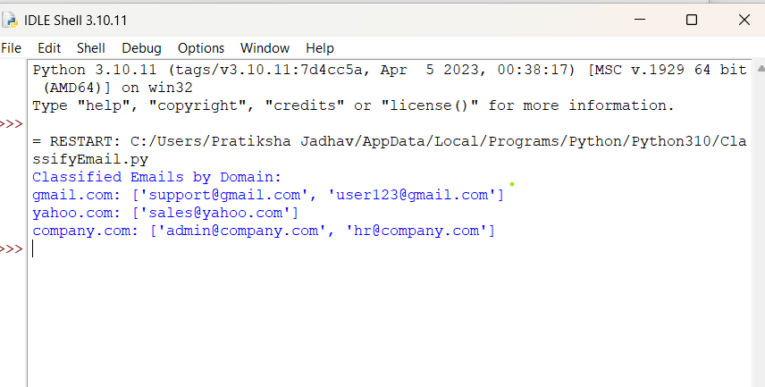
Q15. Create threads to perform independent tasks such as downloading multiple files Simultaneously

import threading
import time

def download_file(filename):
print(f"Starting download: {filename}")
time.sleep(2) # Simulate download time
print(f"Finished downloading: {filename}")

# List of files
files = ["file1.jpg", "file2.mp4", "file3.pdf", "file4.png"]

threads = []

# Create and start threads
for file in files:
t = threading.Thread(target=download_file, args=(file,))
threads.append(t)
t.start()

# Wait for all threads to finish
for t in threads:
t.join()
print("All downloads completed.")

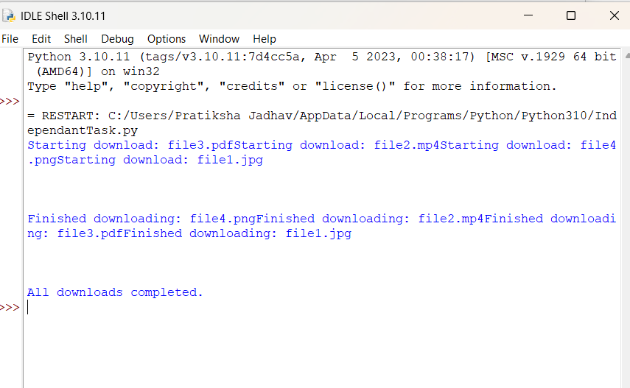
Q 16. Write a Python program to create two threads. The first thread will print even numbers, and the second thread will print odd numbers. Demonstrate the concept of multithreading.

import threading
import time
def print_even():
for i in range(0, 21, 2):
print("Even:", i)
time.sleep(0.2)
def print_odd():
for i in range(1, 21, 2):
print("Odd :", i)
time.sleep(0.2)

t1 = threading.Thread(target=print_even)
t2 = threading.Thread(target=print_odd)
t1.start()
t2.start()
t1.join()
t2.join()
print("Both threads finished execution.")

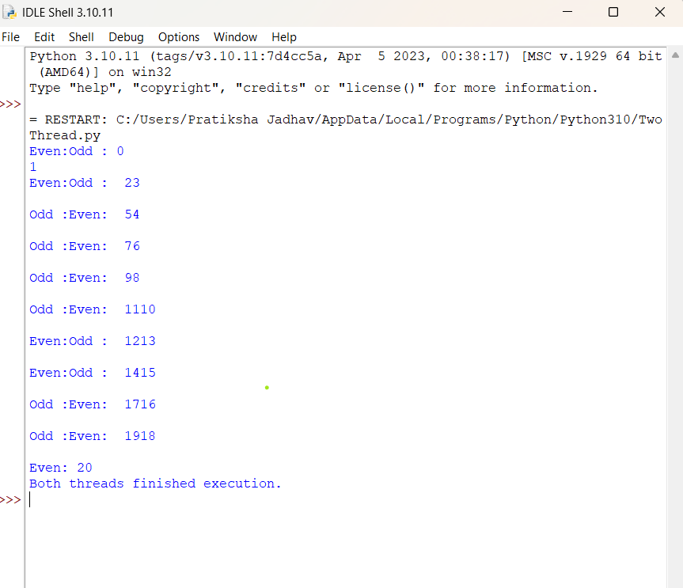

Q17. Use multithreading to compute factorials of multiple numbers and log the results into a file.

import threading
import math

def compute_factorial(n):
result = math.factorial(n)
with open("factorial_log.txt", "a") as file:
file.write(f"Factorial of {n} = {result}\n")
print(f"Computed factorial of {n}")

numbers = [5, 7, 10, 12, 15]

threads = []

# Create and start threads
for num in numbers:
t = threading.Thread(target=compute_factorial, args=(num,))
threads.append(t)
t.start()
for t in threads:
t.join()
print("All factorials computed and logged.")

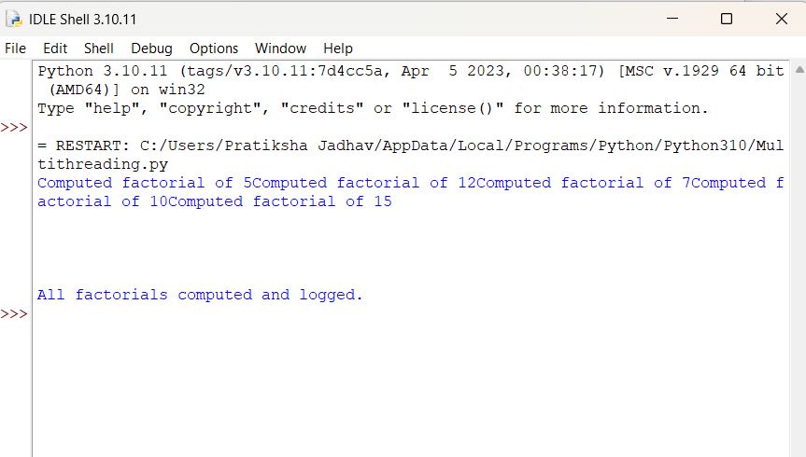
Assignment No : 4

Q1. Develop a Python program to create, read, update, and delete documents in a MongoDB collection.

from pymongo import MongoClient
# Connect to MongoDB
client = MongoClient("mongodb://localhost:27017/")
db = client["assignment4"]
collection = db["demo_collection"]
# ---- CREATE ----
document = {"name": "Amit", "age": 25, "city": "Pune"}
collection.insert_one(document)
print("Document Inserted")
# ---- READ ----
print("\nAll Documents:")
for doc in collection.find():
print(doc)
# ---- UPDATE ----
collection.update_one({"name": "Amit"}, {"$set": {"age": 30}})
print("\nAfter Update:")
print(collection.find_one({"name": "Amit"}))
# ---- DELETE ----
collection.delete_one({"name": "Amit"})
print("\nAfter Delete:")
for doc in collection.find():
print(doc)

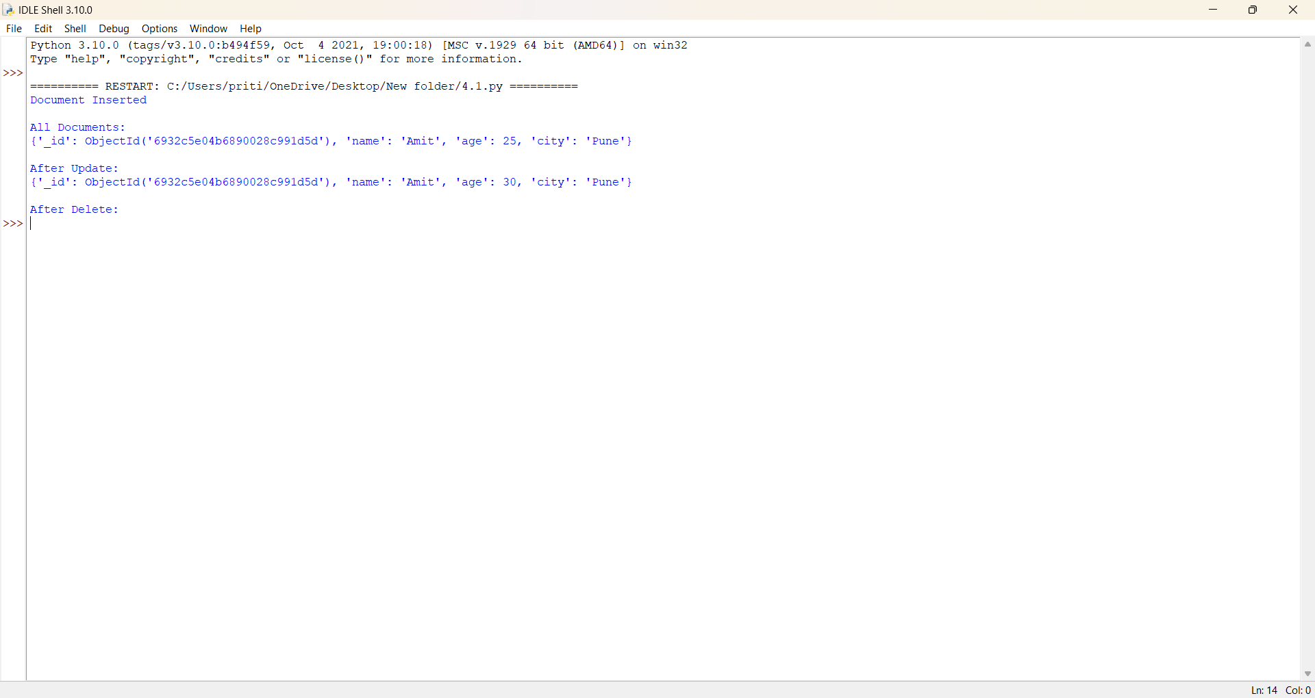
Q2. Write a program to insert valid data into MongoDB using exception handling for errors.

from pymongo import MongoClient, errors
client = MongoClient("mongodb://localhost:27017/")
db = client["assignment4"]
collection = db["student_records"]
data = {"name": "Riya", "age": 20}

try:
if not isinstance(data["age"], int):
raise ValueError("Age must be a number")

collection.insert_one(data)
print("Data Inserted Successfully")
except ValueError as ve:
print("Validation Error:", ve)
except errors.PyMongoError as pe:
print("MongoDB Error:",pe)

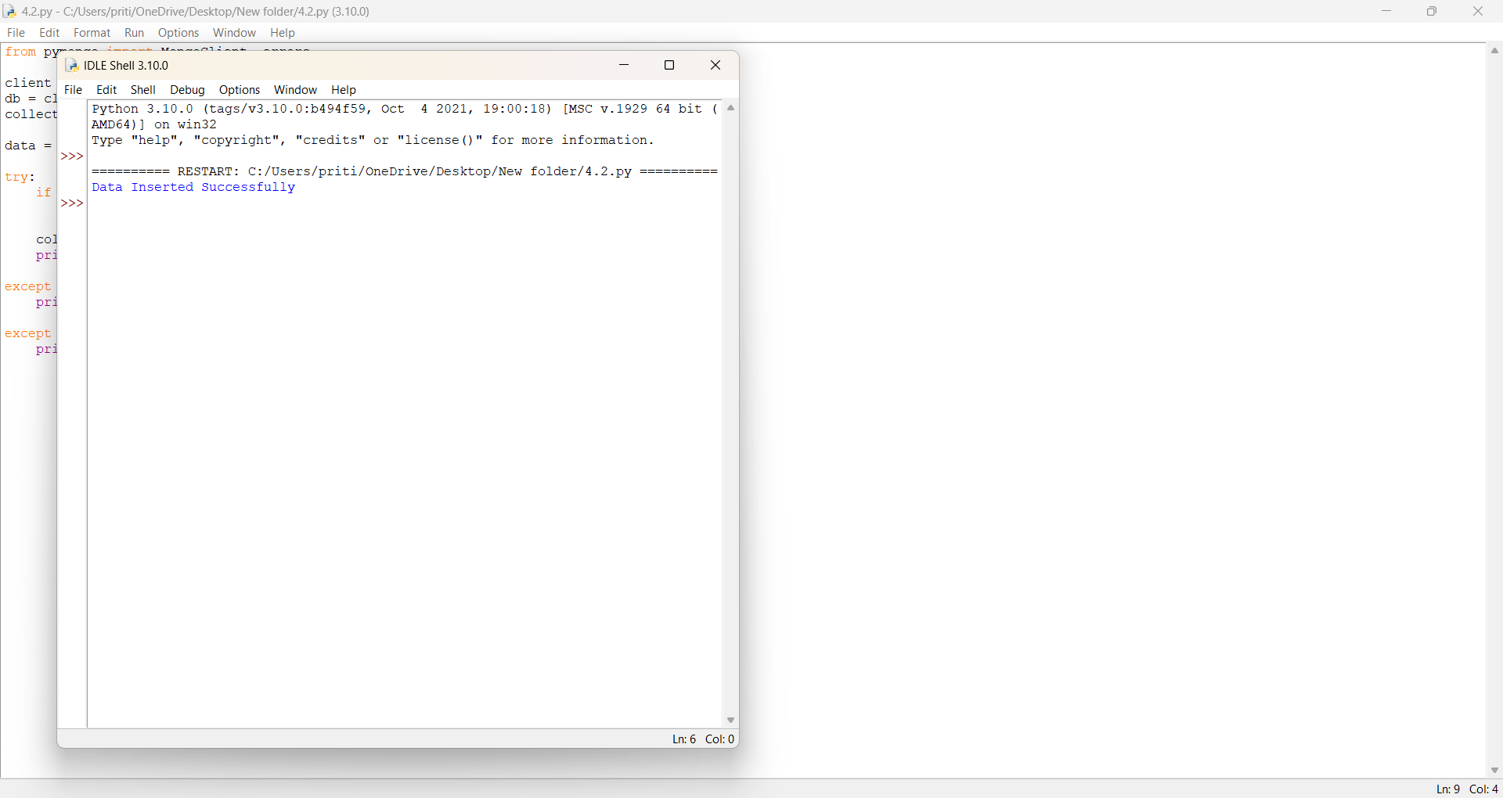

Q3. Use MongoDB's aggregation pipeline to find the average salary of employees in a collection.

client = MongoClient("mongodb://localhost:27017/")
db = client["assignment4"]
collection = db["employees"]
# Sample Data (Run once only)
sample = [
{"name": "John", "salary": 40000},
{"name": "Sara", "salary": 50000},
{"name": "Amit", "salary": 45000},
]
collection.insert_many(sample)

pipeline = [
{"$group": {"_id": None, "avg_salary": {"$avg": "$salary"}}}
]
result = list(collection.aggregate(pipeline))
print("Average Salary:", result[0]["avg_salary"])

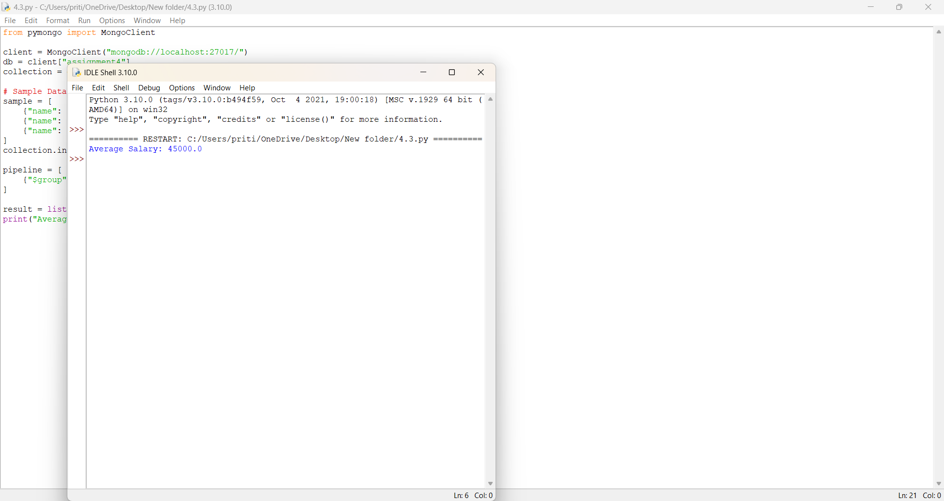

Q4. Develop a Python program to create a database name employee. With the collection name empinfo. Add 5 douments in the collection. Perform read, update, and delete operations on documents in a MongoDB..
from pymongo import MongoClient
client = MongoClient("mongodb://localhost:27017/")
db = client["employee"]
collection = db["empinfo"]
# Add 5 documents
employees = [
{"empid": 1, "name": "Amit", "salary": 45000},
{"empid": 2, "name": "Riya", "salary": 55000},
{"empid": 3, "name": "Neha", "salary": 60000},
{"empid": 4, "name": "Karan", "salary": 50000},
{"empid": 5, "name": "Sanjay", "salary": 47000}
]
collection.insert_many(employees)
print("5 Employee Records Inserted")
# ---- READ ----
print("\nAll Employees:")
for emp in collection.find():
print(emp)
# ---- UPDATE ----
collection.update_one({"empid": 3}, {"$set": {"salary": 65000}})
print("\nAfter Update empid=3:")
print(collection.find_one({"empid": 3}))
# ---- DELETE ----
collection.delete_one({"empid": 5})
print("\nAfter Deleting empid=5:")
for emp in collection.find():
print(emp)
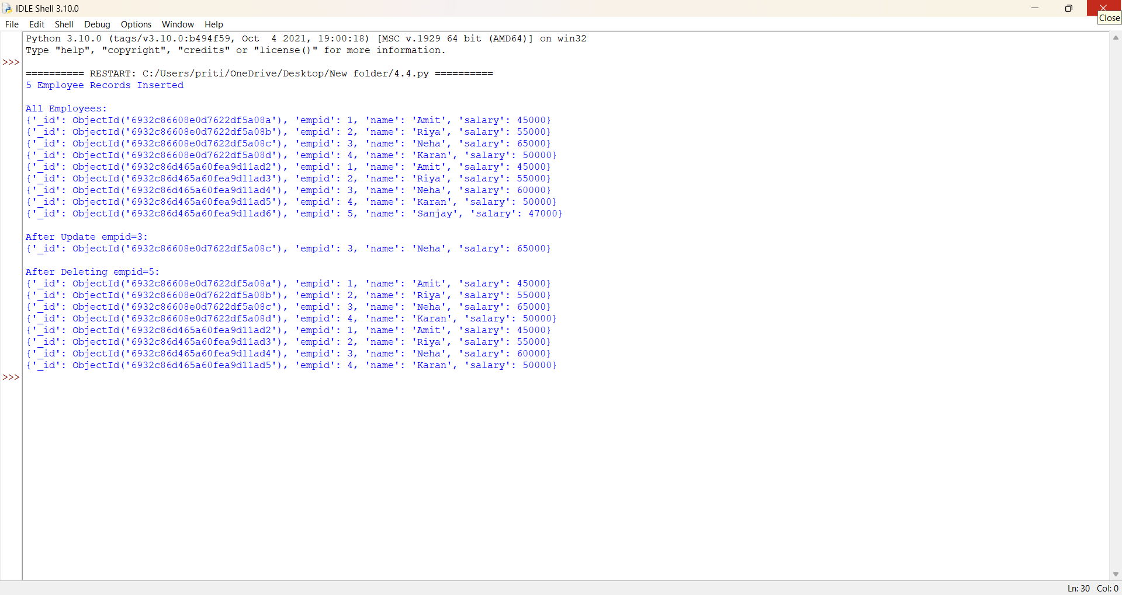
Assignment No : 5

Q1. Create a Django project with models for Product and Category, along with views to display them on a webpage.
PROGRAM:
1️⃣ Create Django Project
django-admin startproject myproject
cd myproject
2️⃣ Create App
python manage.py startapp shop
3️⃣ Add App in settings.py
Open myproject/settings.py → add:
INSTALLED_APPS = [
...
'shop',
]
4️⃣ Create Models
Open shop/models.py:
class Category(models.Model):
name = models.CharField(max_length=100)

class Product(models.Model):
category = models.ForeignKey(Category, on_delete=models.CASCADE)
name = models.CharField(max_length=100)
price = models.FloatField()
description = models.TextField()
5️⃣ Make Migrations
python manage.py makemigrations
python manage.py migrate
6️⃣ Create View
Open shop/views.py:
def product_list(request):
products = Product.objects.all()
return render(request, 'product_list.html', {'products': products})
7️⃣ Create Template
Create file:
shop/templates/product_list.html
Add:
<h1>Product List</h1>
{% for p in products %}
<p>{{ p.name }} - ₹{{ p.price }} - {{ p.category.name }}</p>
{% endfor %}
8️⃣ Create shop/urls.py
from django.urls import path
from .views import product_list

urlpatterns = [
path('', product_list),
]
9️⃣ Add URL in project urls.py
Open myproject/urls.py:
from django.urls import path, include

urlpatterns = [
path('', include('shop.urls')),
]
🔟 Run Server
python manage.py runserver
Open in browser:
http://127.0.0.1:8000/
You will see the Product List Page.
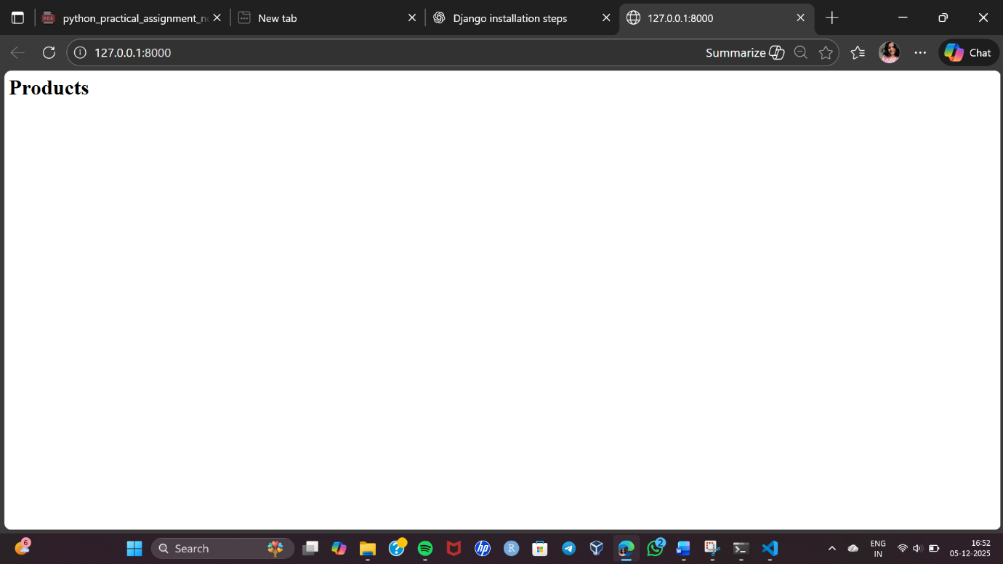

Q2. Implement user login, logout, and registration functionality in Django.
PROGRAM:

Step 1: Create Django Project & App
"C:\Program Files\Python310\python.exe" -m django startproject myproject
cd authproject
python manage.py startapp accounts
Add the app in settings.py
INSTALLED_APPS = [
...
'accounts',
]
Step 2: Create Registration Form
Use Django’s built-in UserCreationForm.
accounts/forms.py
from django.contrib.auth.forms import UserCreationForm
from django.contrib.auth.models import User
class RegisterForm(UserCreationForm):
class Meta:
model = User
fields = ['username', 'password1', 'password2']
Step 3: Create Views for Register, Login & Logout
accounts/views.py
from django.shortcuts import render, redirect
from django.contrib.auth import authenticate, login, logout
from django.contrib.auth.forms import AuthenticationForm
from .forms import RegisterForm
# Register User
def register_user(request):
if request.method == 'POST':
form = RegisterForm(request.POST)
if form.is_valid():
form.save()
return redirect('login_user')
else:
form = RegisterForm()
return render(request, 'register.html', {'form': form})
# Login User
def login_user(request):
if request.method == 'POST':
form = AuthenticationForm(request, data=request.POST)
if form.is_valid():
username = form.cleaned_data.get('username')
password = form.cleaned_data.get('password')
user = authenticate(username=username, password=password)
if user:
login(request, user)
return redirect('home')
else:
form = AuthenticationForm()
return render(request, 'login.html', {'form': form})
# Logout User
def logout_user(request):
logout(request)
return redirect('login_user')
Step 4: Create URLs
authproject/urls.py
from django.contrib import admin
from django.urls import path
from accounts import views
urlpatterns = [
path('admin/', admin.site.urls),
path('', views.login_user, name='home'), # default page
path('register/', views.register_user, name='register_user'),
path('login/', views.login_user, name='login_user'),
path('logout/', views.logout_user, name='logout_user'),
]
Step 5: Create Templates
Create folder:
📁 accounts/templates/
Inside create:
- register.html
- login.html
register.html
<h2>Register</h2>
<form method="POST">
{% csrf_token %}
{{ form.as_p }}
<button type="submit">Register</button>
</form>
<a href="{% url 'login_user' %}">Already have an account? Login</a>
login.html
<h2>Login</h2>
<form method="POST">
{% csrf_token %}
{{ form.as_p }}
<button type="submit">Login</button>
</form>
<a href="{% url 'register_user' %}">Create new account</a>
Step 6: Run Server
python manage.py migrate
python manage.py runserver
Open in browser:
http://127.0.0.1:8000/
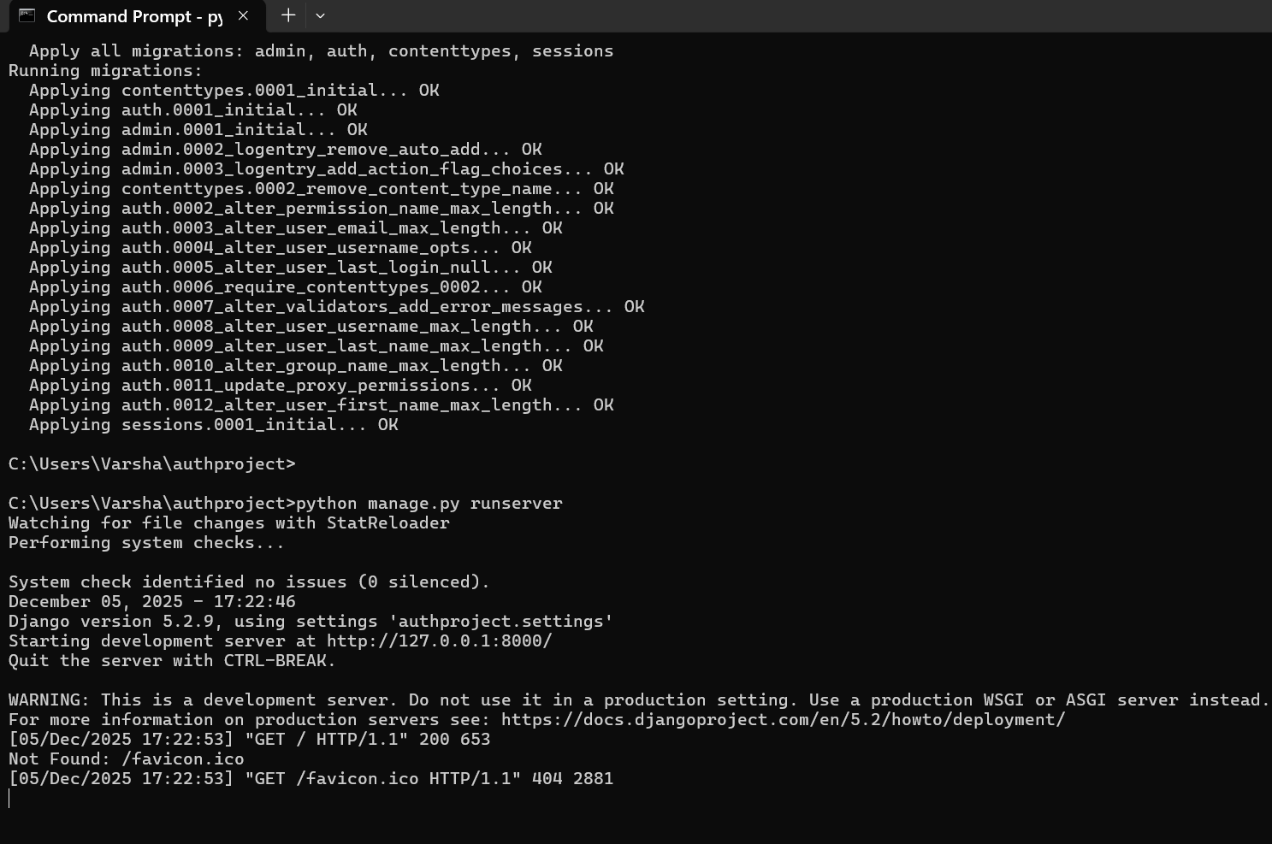
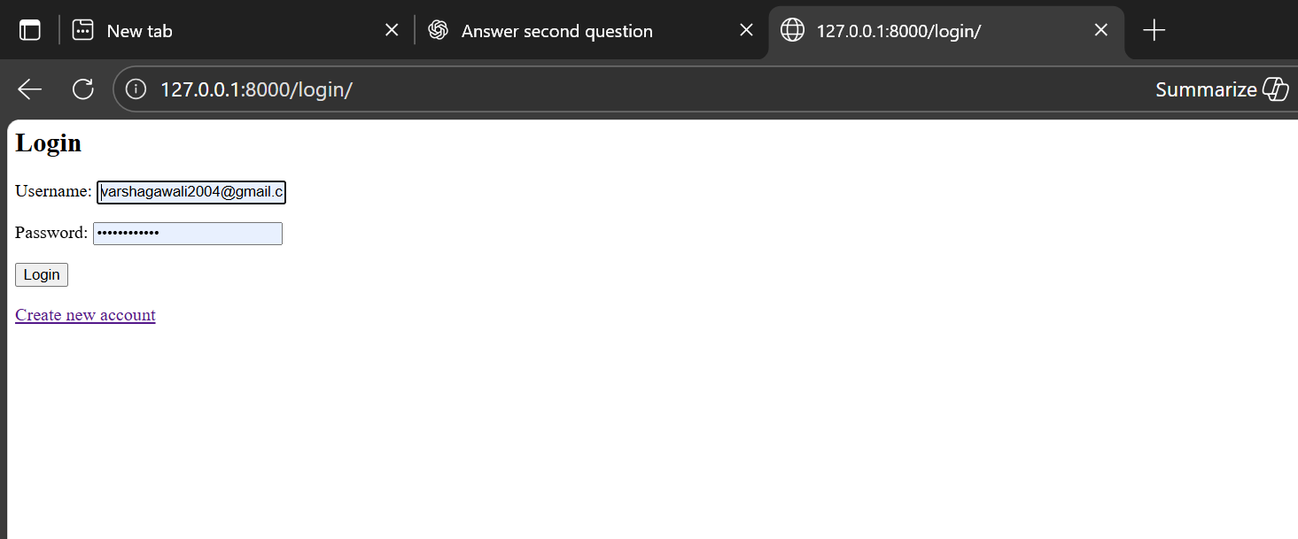

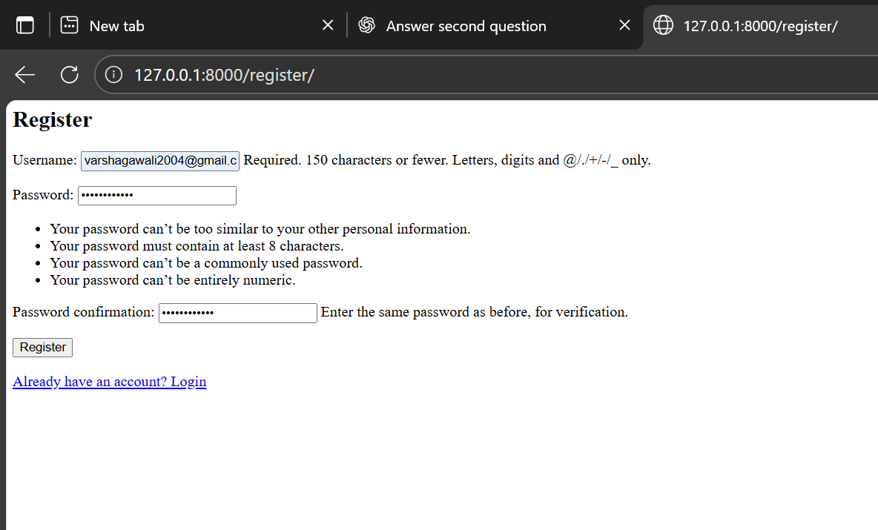

Q3. Build a REST API for a task management system where users can create, update, and delete tasks.
PROGRAM:
1. Install Django and DRF
pip install django djangorestframework

2. Create Django project and app
django-admin startproject taskmanager
cd taskmanager
python manage.py startapp tasks

3. Add apps to settings.py
INSTALLED_APPS = [
...
'rest_framework',
'tasks',
]
4. Create Task model (tasks/models.py)
from django.db import models
from django.contrib.auth.models import User
class Task(models.Model):
user = models.ForeignKey(User, on_delete=models.CASCADE)
title = models.CharField(max_length=200)
description = models.TextField(blank=True)
completed = models.BooleanField(default=False)
created_at = models.DateTimeField(auto_now_add=True)
def __str__(self):
return self.title
5. Make migrations
python manage.py makemigrations
python manage.py migrate
6. Create a Serializer (tasks/serializers.py)
from rest_framework import serializers
from .models import Task
class TaskSerializer(serializers.ModelSerializer):
class Meta:
model = Task
fields = '__all__'
7. Create API Views (tasks/views.py)
from rest_framework import viewsets, permissions
from .models import Task
from .serializers import TaskSerializer
class TaskViewSet(viewsets.ModelViewSet):
queryset = Task.objects.all()
serializer_class = TaskSerializer
permission_classes = [permissions.IsAuthenticated]
def get_queryset(self):
return self.queryset.filter(user=self.request.user)
def perform_create(self, serializer):
serializer.save(user=self.request.user)
8. Set up URLs (tasks/urls.py)
from django.urls import path, include
from rest_framework.routers import DefaultRouter
from .views import TaskViewSet
router = DefaultRouter()
router.register(r'tasks', TaskViewSet, basename='task')
urlpatterns = [
path('', include(router.urls)),
]
9. Include app URLs in project (taskmanager/urls.py)
from django.contrib import admin
from django.urls import path, include
urlpatterns = [
path('admin/', admin.site.urls),
path('api/', include('tasks.urls')),
]
10. Create superuser & run server
python manage.py createsuperuser
python manage.py runserver

